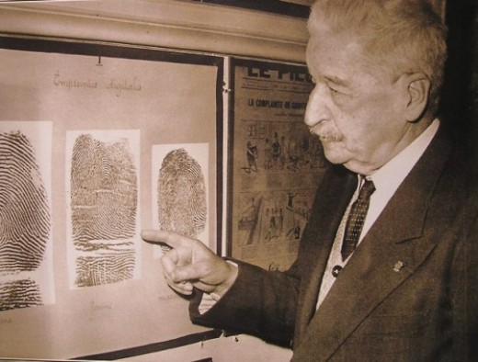
Locard's exchange principle:
"Every contact leaves a trace".

Forensic Science 3202
Course Syllabus

Credits: 0.5
Mrs. Cassidy Room C121, ccassidy@rsd17.org

The mission of Haddam-Killingworth High School is to provide a personalized and collective experience through which students are challenged to develop the knowledge, skills, and work ethic to contribute to a global society.

I. Course Description
The purpose of this course is to provide students with an introduction to modern methodologies, theoretical understanding and practical application of scientific methods related to forensic science. This course will focus on collection and analysis of crime scene evidence and will explore lab analysis techniques. An understanding of the relationship between forensic science and legal studies will also be investigated through case studies, mock crime scene investigations and evidence collection, examination, evaluation and interpretation.

II. Course Concepts
- Crime-Scene Investigation and Evidence Collection
- Hair
- Fibers and Textiles
- Fingerprinting
- Handwriting Analysis/Document Analysis
- Trace Evidence
- Additional topics may be covered

III. Class Supplies/Materials
All students must have the following supplies/materials for the entire semester:
- Several writing implements (pens/pencils)
- Three-ring binder/notebook with loose-leaf paper to be used only for Forensic Science
- Agenda issued by HKHS
- *Textbook – Forensic Science Fundamentals & Investigations (available in class)

IV. Course Expectations
- HKHS Grading System and Attendance Policy – in compliance with the HKHS Student Handbook.
- Notebook Requirements – You will be required to maintain a thorough notebook that details what you have learned in this class. Your notebook should include vocabulary, notes, worksheets, reference sheets, etc. All graded assignments and any reference materials should also be filed into your notebook. Keeping an organized notebook will help you later in the course when you study for the cumulative final. Completion of a notebook is your sole responsibility.
- Absences - It is your responsibility to make-up any class time you miss. Upon your return class, please see the instructor to schedule after school help. Make-up work will not be done during regular class time. Absences will not delay any assessment except under special circumstances approved by your instructor. If you are absent on the day of an assessment, you will take the assessment (test, etc.) on the next day you are present.

V. Grading Policy
- Grades will be calculated using a percent system
- Calculation of marking period grades
  - 60% Laboratory experiences, projects,
  - 40% Tests
- Calculation of final grade
  - Quarter 1 40%
  - Quarter 2 40%
  - Final Exam 20%
- Grades can be accessed online through Power School.

VI. Electronic Devices Policy (from HK Handbook)
Cell phones and all other electronic devices (e.g. ipods) may not be used during class periods except when technology is explicitly used for instruction and learning under the direction of the teacher. The only acceptable place and time to use an electronic device such as a cell phone is during passing time and lunch- and only in the hallways and in the cafeteria. Student tardiness to class due to phone use is NOT acceptable, nor is leaving class to use the phone in the hallway or lavatory. In addition, headphones (earbuds, etc.) shall not be used at all except in the cafeteria during lunch. This is to encourage appropriate social interactions between students in the hallways and avoid the safety hazard caused by students unable to hear instructions, announcements, etc.
VII. Instructors Expectations:
- Do excellent work the first time. There are no extra credit opportunities to supplement poor grades or zeros. Students earn their grades they are not given.
- Follow directions the first time they are given.
- Come to class prepared with all materials including homework. Being prepared for class is fundamental for success.
- Be in your assigned seat and ready to work when the bell rings.
- Assignments are expected to be completed by the due date. Labs and projects turned in after the due date will be assessed in the following manner.
  - Assignments that are turned in late will be assessed at one letter grade lower.
- To assist you with this policy, please write down all assignments daily/weekly in your agenda.
- If you feel you are falling behind or not understanding the material, please see your instructor as soon as possible. Be a proactive, self-advocate.
- HAVE A GREAT SEMESTER AND GOOD LUCK!!

Forensic Science Course Syllabus
Student and Parent/Guardian Acknowledgement

It is important that all students (and parents/guardians) understand the course information and requirements in order to be successful in this class. If you have any questions or concerns at any time, please discuss them with the instructor as soon as possible.

Please check all boxes that apply:
- We have read and understand the syllabus for Forensic Science. | OR | - We have read the syllabus, but need additional information about:
- We will use the Power School to review grades and progress. | OR | - We do not have reliable internet access and will need assistance in staying updated about coursework and grades.

______________________________ ______________________________ ____________
Student Name Student Signature Date

______________________________ ______________________________ ____________
Parent/Guardian Name Parent/Guardian Signature Date

